DESIGN AND ANALYSIS OF ALGORITHMS (DAA)
Agriculture Irrigation Planner

Optimal Water Allocation Across Crops using
Dynamic Programming and Greedy Algorithms
Core Algorithms: Dynamic Programming, Greedy
Suggested Technologies: Python, Flask, SQLite
Project Report
Submitted by: ____________________________
Roll Number: ____________________________
Guide / Faculty: ____________________________
Department / Institution: ____________________________
Academic Year: 2026
Table of Contents
1. Abstract & Introduction 3
2. Problem Statement, Objectives & Scope 5
3. Features & Functional Requirements 7
4. Algorithms & Methodology 10
5. Technologies & Implementation 14
6. Results, Testing & Performance 18
7. Conclusion, Future Scope & References 22

This report documents the design, algorithms, implementation and evaluation of the Agriculture Irrigation Planner, an algorithm-centric prototype that allocates a limited water supply among crops so that total expected yield is maximized while every crop still receives at least its minimum irrigation requirement. All numerical results in Section 6 were produced by running the Python reference implementation described in Section 5.

1. Abstract & Introduction

1.1 Abstract
Water is the most constrained input in modern agriculture. A farm, canal command area or irrigation cooperative usually has a fixed quantity of water per season, while the crops that compete for it respond differently to every additional unit: some saturate quickly, others need a threshold amount before they respond at all, and each has a minimum below which the crop fails. Deciding who gets how much is a combinatorial optimization problem, and a poor split silently costs yield.
This project presents the Agriculture Irrigation Planner, a working prototype that converts this real-world requirement into an explainable algorithmic solution. The planner accepts a list of crops, each with a minimum and maximum water requirement and an expected-yield curve, together with the total water available. It then computes an allocation using two strategies: a Dynamic Programming (DP) planner that stores the best result of every sub-problem and reconstructs the globally optimal allocation, and a Greedy planner that repeatedly gives the next unit of water to the crop with the highest marginal gain.
The system is implemented in Python with Flask for the web interface and SQLite for persistence. Beyond returning a final number, it records and displays the decisions that led to the answer: the DP table, the reconstructed path, and the ordered greedy choices with their marginal gains. In our experiments the DP planner matched an exhaustive brute-force search in 200 of 200 random instances. Greedy matched DP in every instance with concave yield curves, but on instances containing threshold (sigmoid) yield curves it matched in only 87 of 200 cases, with an average yield gap of 5.17% and a worst case of 40.23%. In exchange, greedy was between 25 and 380 times faster than DP on the tested sizes.
Keywords: irrigation planning, water allocation, dynamic programming, greedy algorithm, resource allocation, knapsack, explainable optimization, Flask, SQLite.

1.2 Introduction
Agriculture accounts for the largest share of freshwater withdrawals in most countries, and in many regions, including semi-arid parts of India, seasonal water availability is the binding limit on production. Reservoir releases, groundwater quotas and canal schedules fix how much water can be delivered, but the question of how to divide that water among competing crops is often settled by habit or rule of thumb. Because crops respond differently to irrigation, a uniform or proportional split is rarely the best one.
From an algorithmic point of view the question is a resource allocation problem with separable, non-linear objectives. Each crop contributes a yield that depends only on its own water, the contributions add up, and the water they consume is bounded by a single shared budget. This is closely related to the classical knapsack problem and is a textbook setting for studying the contrast between dynamic programming, which is exact, and greedy methods, which are fast but guaranteed optimal only under additional structure.

1.3 Motivation
- Scarcity: a small improvement in allocation efficiency translates directly into more produce from the same water.
- Non-linear crop response: yield curves show diminishing returns (concave) or a threshold effect (sigmoid), so intuition about "equal shares" or "most valuable crop first" can fail.
- Need for transparency: farmers and planners are far more likely to trust a plan when they can see why each crop received its share.
- Educational value: the problem lets two core design paradigms, DP and greedy, be compared on the same input with measurable outcomes.

1.4 Overview of the Approach
The prototype follows a five-stage pipeline. First, crop data and the water budget are captured and validated. Second, the minimum requirements are reserved so that feasibility is guaranteed. Third, the remaining water is distributed by the selected algorithm. Fourth, the decision trail is recorded. Fifth, the result, the objective value and the explanation are stored in SQLite and displayed to the user. Running both algorithms on the same input allows their allocations, yields and running times to be compared side by side.

1.5 Organization of the Report
Section 2 states the problem formally and defines objectives and scope. Section 3 lists the features and functional requirements. Section 4 explains the algorithms and methodology, including recurrences, pseudo-code, complexity and a worked example. Section 5 describes the technologies and implementation. Section 6 reports testing, results and performance measurements. Section 7 concludes, outlines future scope and lists references.

2. Problem Statement, Objectives & Scope

2.1 Problem Statement
Allocate limited water across crops to maximize expected yield while satisfying minimum irrigation requirements.
The Agriculture Irrigation Planner should convert this real-world requirement into a working, algorithm-centric prototype. The system must accept the entities and values needed for the challenge (crops, water limits, yield behaviour and the total water supply), represent them with appropriate data structures, and produce a solution that is understandable to the user rather than only a final number. The important decisions, namely the assignments of water to crops, must be visible, and the resulting objective value must be shown together with enough information to explain why the result was selected.

2.2 Formal Definition
Let there be n crops indexed i = 1..n and a total water supply of W discrete units. For each crop i the following are given:
- m_i, the minimum number of water units the crop needs (the minimum irrigation requirement);
- M_i, the maximum number of units the crop can usefully absorb (m_i ≤ M_i);
- f_i(x), the expected yield when the crop receives x units, defined for m_i ≤ x ≤ M_i.
The task is to choose integers x_1..x_n that solve:
maximize Σ f_i(x_i) subject to Σ x_i ≤ W, m_i ≤ x_i ≤ M_i for all i
The problem is feasible if and only if Σ m_i ≤ W. If the minimum requirements alone exceed the supply, no valid plan exists and the system must report this clearly rather than return a partial answer.

2.3 Illustrative Example
Consider three crops sharing 20 units of water. Wheat needs at least 3 units, rice at least 5 and maize at least 2, so 10 units are committed immediately and 10 units remain to be distributed. Each extra unit has a different marginal benefit for each crop, and the planner has to decide how to spend the 10 free units. The sections that follow show how DP and greedy approach this decision and why their answers can differ when the yield curves are not concave.

2.4 Objectives
The objectives follow the project brief and are stated here in measurable form.
# | Objective | Measure
O1 | Maximize the stated value: total expected yield of the season | Objective value Σ f_i(x_i), compared against brute force on small cases
O2 | Minimize resource waste: unused or over-applied water | Unallocated units; no crop exceeds M_i
O3 | Satisfy all minimum irrigation requirements | Every x_i ≥ m_i; infeasible inputs rejected with a message
O4 | Demonstrate the selected DAA algorithms (DP and Greedy) | Both implemented, instrumented and runnable on identical input
O5 | Compare behaviour of the two approaches | Yield, optimality gap and running time reported side by side
O6 | Make decisions understandable | DP table, reconstructed path and ordered greedy choices shown in the UI

2.5 Scope

In scope
- Single-season allocation of one shared, discrete water budget among a configurable list of crops.
- Concave (diminishing returns) and sigmoid (threshold) yield models, plus user-supplied yield tables.
- Exact DP solution with reconstruction, and greedy marginal-gain heuristic.
- Persistent storage of crops, plans and allocations; comparison and explanation views.

Out of scope
- Real-time sensor integration, weather forecasting and soil-moisture modelling.
- Hydraulic modelling of canals or pipes, and conveyance losses.
- Economic optimization with market prices (considered as future work).
- Multi-season or multi-field crop rotation planning.

2.6 Assumptions and Constraints
- Water is allocated in integer units (for example 1 unit = 1,000 m³ or a fixed depth over the field area), which keeps the state space finite.
- Crop yields are independent: the yield of one crop does not depend on how much water another receives.
- Yield functions are non-negative and non-decreasing between m_i and M_i.
- The total supply W is known in advance and does not change during the season.
- Expected yield is treated as a deterministic function; stochastic variation is future work.

2.7 Expected Deliverables
- A Python library with DP, greedy and brute-force reference solvers.
- A Flask web application backed by an SQLite database.
- Explanations of each decision, comparison charts and a test suite.
- This project report.

3. Features & Functional Requirements

3.1 Feature Overview
The prototype is intentionally small in surface area so that the algorithms stay at the centre. Its features fall into five groups.
Group | Feature | Description
Data entry | Crop management | Add, edit and delete crops with name, minimum water, maximum water and a yield model or table.
Data entry | Season setup | Specify the total water available W and the planning unit.
Planning | Feasibility check | Verify Σ m_i ≤ W before any optimization runs.
Planning | DP planner | Compute the optimal allocation and total expected yield.
Planning | Greedy planner | Compute the marginal-gain allocation and total expected yield.
Explanation | Decision trace | Show the DP table, the backtracking path and the ordered greedy choices.
Comparison | Side-by-side view | Compare allocations, yield, gap to optimum and runtime of both algorithms.
Persistence | History | Store every plan and its allocations in SQLite for later review.

3.2 Functional Requirements
ID | Requirement | Priority
FR-01 | The system shall allow the user to create, update, list and delete crops with a name, minimum water m_i and maximum water M_i. | High
FR-02 | The system shall allow a yield model to be chosen per crop (concave with parameters a and b, sigmoid with parameters a, k and x0, or an explicit table). | High
FR-03 | The system shall accept the total available water W as a positive integer. | High
FR-04 | The system shall verify feasibility (Σ m_i ≤ W) and show a clear error naming the shortfall when it fails. | High
FR-05 | The system shall compute the optimal allocation using Dynamic Programming and report the maximum total expected yield. | High
FR-06 | The system shall compute an allocation using the Greedy marginal-gain rule and report the total expected yield. | High
FR-07 | The system shall guarantee that every allocation satisfies m_i ≤ x_i ≤ M_i and Σ x_i ≤ W. | High
FR-08 | The system shall display the DP table of sub-problem results and the path reconstructed from it. | High
FR-09 | The system shall display each greedy step: the crop chosen, its new allocation and the marginal gain that justified the choice. | High
FR-10 | The system shall present both algorithms on one screen with yield difference, percentage gap and execution time. | Medium
FR-11 | The system shall store each plan (inputs, algorithm, objective value, allocations, runtime) in SQLite and allow it to be reopened. | Medium
FR-12 | The system shall export a plan as CSV or JSON. | Low
FR-13 | The system shall offer an optional brute-force verifier for small instances. | Low

3.3 Non-Functional Requirements
ID | Category | Requirement
NFR-01 | Correctness | DP results must equal exhaustive search on all verification instances.
NFR-02 | Performance | For n ≤ 20 crops and W ≤ 200 units both planners should respond in under one second on a laptop.
NFR-03 | Explainability | Every number in the result must be traceable to a displayed decision.
NFR-04 | Usability | A non-technical user should be able to enter data and read the result without documentation.
NFR-05 | Reliability | Invalid input (negative water, m_i > M_i, missing values) must be rejected with a helpful message.
NFR-06 | Maintainability | Algorithms live in a framework-independent module so they can be tested without Flask.
NFR-07 | Portability | Runs with only Python 3.10+, Flask and the built-in sqlite3 module.

3.4 Use Cases

UC-1: Plan a season
A farm manager enters five crops with their minimum and maximum water, sets W, and presses "Plan". The system checks feasibility, runs both algorithms and shows the DP-optimal allocation, the greedy allocation and a summary of the difference.

UC-2: Understand a recommendation
The manager opens the explanation tab. For DP, the table shows the best yield achievable with the first i crops and w units, and the chosen path highlights which cell each crop's allocation came from. For greedy, an ordered list shows which crop received each additional unit and the marginal gain at that moment.

UC-3: What if water drops?
The manager lowers W by ten units and re-runs. If the minimums can no longer be met, the system explains the shortfall; otherwise it shows how the allocation shifts, enabling a conversation about which crop should be sacrificed first.

3.5 Input Validation Rules
- Crop names must be non-empty and unique within a plan.
- 0 ≤ m_i ≤ M_i, and all water quantities are integers.
- W must be greater than zero; if Σ m_i > W the plan is rejected as infeasible.
- Yield parameters must make f_i non-negative and non-decreasing on [m_i, M_i]; tables must list every integer in that range.

3.6 User Interface Flow
- Home page: list of crops with an "Add crop" form and the current water budget.
- Plan page: choose algorithm (DP, Greedy or Both) and run.
- Result page: allocation table, objective value, utilisation of water and comparison summary.
- Explanation page: DP table and path, greedy step list, and a bar chart of per-crop yield.
- History page: previously saved plans with the option to reopen or export them.

4. Algorithms & Methodology

4.1 Methodology Overview
The solution follows the same steps for both algorithms so that they are directly comparable.
- Validate and normalise the inputs; check feasibility Σ m_i ≤ W.
- Reserve minimums: every crop is given m_i units first. This removes the minimum-irrigation constraint from the remaining search and leaves a free budget W′ = W − Σ m_i.
- Distribute the free budget with the DP or greedy strategy.
- Record decisions (table cells, backtracking path, greedy steps) during the computation, not afterwards, so the explanation is faithful to what was executed.
- Report the allocation, objective value, utilisation and runtime, and persist them.

4.2 Problem Structure
The problem has two properties that matter for algorithm design. It has optimal substructure: if an optimal plan gives x_n units to the last crop, then the allocation of the remaining W − x_n units among the first n − 1 crops must itself be optimal for that smaller problem; otherwise it could be swapped for a better one to improve the whole plan. It also has overlapping sub-problems: the question "what is the best yield from the first i crops using at most w units?" is reached through many different combinations of earlier choices. These two properties are exactly the conditions under which dynamic programming is effective.
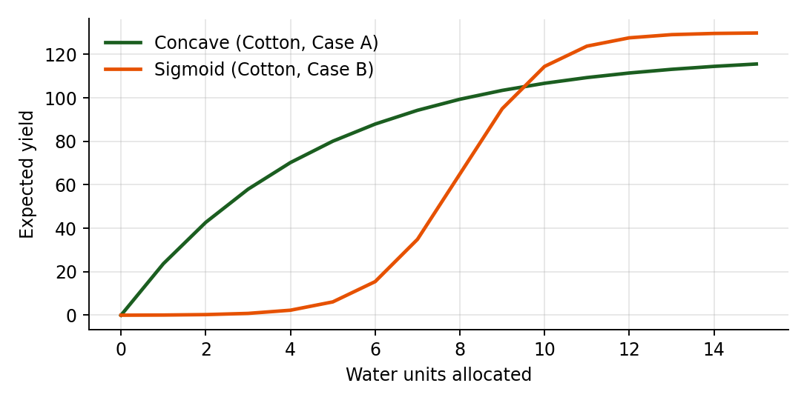
Figure 4.1: Two yield behaviours. The concave curve has diminishing returns; the sigmoid curve gives almost nothing until a threshold is reached.

4.3 Dynamic Programming Planner

4.3.1 Sub-problem definition
Define dp[i][w] as the maximum total expected yield obtainable from the first i crops when at most w units of water are available, with every one of those crops receiving at least its minimum. The answer to the whole problem is dp[n][W]. Alongside the value, choice[i][w] stores the amount x given to crop i in the best solution for that cell, which allows the plan to be reconstructed.

4.3.2 Recurrence
dp[0][w] = 0 for all w ≥ 0
dp[i][w] = max over x in [m_i , min(M_i , w)] of { dp[i−1][w − x] + f_i(x) }
If no x gives a valid sub-solution (for example the first i crops cannot meet their minimums within w units), the cell is marked infeasible (−∞). This is how minimum irrigation is enforced inside the recurrence itself.

4.3.3 Pseudo-code
DP-PLAN(crops, W):
for w in 0..W: dp[0][w] = 0
for i in 1..n:
for w in 0..W:
best = -inf
for x in m[i] .. min(M[i], w):
if dp[i-1][w-x] is feasible and dp[i-1][w-x] + f_i(x) > best:
best = dp[i-1][w-x] + f_i(x); choice[i][w] = x
dp[i][w] = best
w = W
for i = n down to 1: // reconstruction
alloc[i] = choice[i][w]; w = w - alloc[i]
return dp[n][W], alloc

4.3.4 Complexity and correctness
There are n × (W + 1) cells and each tries at most K = max(M_i − m_i) + 1 values of x, so time is O(n · W · K), which is at most O(n · W²), and space is O(n · W) because the choice table is kept for reconstruction. This is pseudo-polynomial: it is polynomial in the numeric value of W rather than in the number of bits needed to write it, which is acceptable because W is a modest number of planning units.
Correctness follows by induction on i. For i = 0 the table is trivially optimal. Assuming dp[i−1][·] is optimal for every budget, dp[i][w] considers every feasible amount x for crop i and combines it with the optimal solution for the remaining budget; by optimal substructure no better combination can exist. The reconstruction walks the stored choices from (n, W) backwards, so the returned allocation attains exactly dp[n][W].

4.3.5 Worked example
Take the first three crops of the test data (Wheat m=3, Rice m=5, Maize m=2) and W = 20. Selected cells of the DP table are shown below; "–" marks cells where the minimums cannot be met.
After crop | w = 6 | w = 10 | w = 14 | w = 18 | w = 20
none (i=0) | 0.0 | 0.0 | 0.0 | 0.0 | 0.0
Wheat (i=1) | 83.5 | 95.0 | 97.3 | 97.3 | 97.3
+ Rice (i=2) | – | 162.3 | 190.3 | 208.4 | 214.8
+ Maize (i=3) | – | 187.7 | 230.1 | 258.9 | 270.1
Table 4.1: Selected DP cells (best expected yield with at most w units). Infeasible cells shown as –.
The answer is dp[3][20] = 270.12. Backtracking: the last cell's stored choice gives Maize 5 units, leaving 15; the cell (2, 15) stores Rice 9 units, leaving 6; the cell (1, 6) stores Wheat 6 units. The allocation is therefore Wheat 6, Rice 9, Maize 5. Each number is traceable to a stored cell, which is what the explanation view displays.

4.4 Greedy Planner

4.4.1 Greedy rule
After reserving the minimum for every crop, the greedy planner gives the remaining water one unit at a time. At each step it chooses the locally best feasible move: the crop whose next unit produces the largest increase in yield (the marginal gain Δ_i = f_i(x_i + 1) − f_i(x_i)), among crops not yet at their maximum. A max-heap keyed on Δ_i keeps this choice efficient; after a crop receives a unit its new marginal gain is recomputed and reinserted. The loop stops when the water is exhausted, all crops are saturated, or the best remaining gain is not positive.

4.4.2 Pseudo-code
GREEDY-PLAN(crops, W):
alloc[i] = m[i] for all i; left = W - sum(m)
heap = { (f_i(m_i+1) - f_i(m_i), i) for each crop with m_i < M_i }
while left > 0 and heap not empty:
(gain, i) = extract-max(heap)
if gain <= 0: break
alloc[i] += 1; left -= 1; log(step, crop i, alloc[i], gain)
if alloc[i] < M[i]: insert (f_i(alloc[i]+1) - f_i(alloc[i]), i)
return sum f_i(alloc[i]), alloc, log

4.4.3 Complexity
Reserving minimums is O(n), building the heap is O(n), and each of the at most W′ steps performs one extraction and one insertion at O(log n). Total time is O(n + W · log n) and space is O(n) plus the log. This is dramatically smaller than the DP cost, which is why greedy remains attractive for very large instances.

4.4.4 When is greedy optimal?
If every f_i is concave, meaning the marginal gain is non-increasing in x, then the greedy choice is optimal. An exchange argument shows why: suppose an optimal solution gave a unit to crop j although crop i had a strictly larger next marginal gain. Moving that unit from j to i would not decrease the total, because concavity guarantees that j's last unit contributed no more than i's next one. Repeating the exchange transforms any optimal solution into the greedy one. Our random tests confirm this: with concave curves, greedy equalled DP in all 200 cases.
If a yield curve is not concave, the argument breaks. A threshold crop has a tiny marginal gain for its first few units and a large one later, so the greedy rule undervalues it and may never invest enough to cross the threshold. The sigmoid cotton curve in Figure 4.1 is an example: its first unit above the minimum is worth very little, but eight units together are worth a lot. Section 6 shows a concrete case where this costs greedy about 15% of the achievable yield.

4.5 Making Decisions Visible
Explainability is a requirement rather than an add-on. Both planners write their trail into an explanation object while they run:
- DP: the table dp, the choice table, and the ordered list of backtracking cells (i, w, x). The UI renders the table with the chosen path highlighted.
- Greedy: an ordered list of steps (step number, crop, new allocation, marginal gain). The user sees directly that, for example, maize received the first extra unit because it offered the highest immediate gain.
- Comparison: per-crop difference between the two allocations and a one-sentence reason where greedy deviates (for example "greedy never funded Cotton past its minimum because its marginal gain stayed below other crops").

4.6 Comparison of the Two Approaches
Aspect | Dynamic Programming | Greedy
Strategy | Solve all sub-problems, store, reconstruct | Best local choice at each step
Optimality | Always optimal | Optimal only for concave yields
Time | O(n · W · K) | O(n + W log n)
Space | O(n · W) | O(n)
Handles thresholds | Yes | No, may miss them
Explanation | Table and backtracking path | Ordered list of choices
Best used when | Accuracy matters and W is moderate | Speed matters or curves are concave
The two strategies are complementary. DP gives the reference answer and handles any yield shape, while greedy provides a fast approximation and, when the curves are known to be concave, a proven-optimal one. The prototype therefore lets the user run both and see the gap.

5. Technologies & Implementation

5.1 Technology Stack
Layer | Technology | Role
Language | Python 3.10+ | Algorithms, data structures, test harness
Web framework | Flask | Routes, form handling, templates, JSON endpoints
Database | SQLite (sqlite3) | Persistent crops, plans and allocations
Templates | Jinja2 + HTML/CSS | Result, comparison and explanation pages
Visualisation | Matplotlib (reports) / Chart.js (optional UI) | Yield curves and comparison charts
Testing | unittest / pytest | Correctness and boundary tests

Python is a natural fit because the algorithms read almost like their pseudo-code and the standard library already provides heapq for the greedy priority queue and sqlite3 for storage. Flask adds a thin web layer without imposing a heavy project structure, and SQLite needs no server, which keeps the prototype self-contained.

5.2 System Architecture
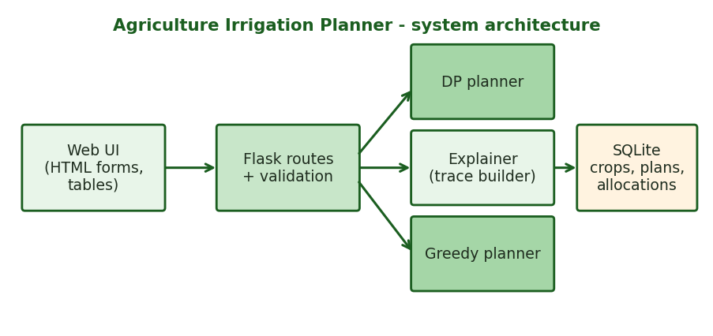
Figure 5.1: Architecture. The planners are independent of Flask and SQLite.
The architecture is layered. The browser submits forms to Flask routes, which validate input and call a planner. Each planner returns an object holding the allocation, the objective value and its explanation trail. The route then stores the result in SQLite and renders it. Keeping the algorithms in a separate module means they can be unit-tested and benchmarked without starting a web server.

5.3 Data Structures
Structure | Used for | Why
Crop object (name, min, max, yield function) | Entities and their parameters | Groups the data each algorithm needs
2-D list dp[i][w] | DP sub-problem values | Direct indexing; O(1) lookup of stored results
2-D list choice[i][w] | Best x for each cell | Enables backtracking reconstruction
Binary max-heap (heapq) | Greedy marginal gains | O(log n) extract-max and insert
List of step records | Explanation trail | Preserves order for display
Allocation vector alloc[1..n] | Final decisions | Compact result stored in the database

5.4 Database Design
Three tables hold the persistent data. A plan references the crops it used by copying their parameters so that old plans remain reproducible even if crops are edited later.
Table | Columns | Purpose
crops | id, name, min_water, max_water, model, params | Master list of crops and yield models
plans | id, created_at, total_water, algorithm, total_yield, runtime_ms, feasible | One row per run of an algorithm
plan_allocations | id, plan_id → plans, crop_name, water_units, expected_yield, step_no, note | One row per crop per plan (and per greedy step note)

CREATE TABLE crops (
id INTEGER PRIMARY KEY, name TEXT UNIQUE NOT NULL,
min_water INTEGER NOT NULL CHECK(min_water >= 0),
max_water INTEGER NOT NULL CHECK(max_water >= min_water),
model TEXT NOT NULL, params TEXT NOT NULL);
CREATE TABLE plans (
id INTEGER PRIMARY KEY, created_at TEXT, total_water INTEGER,
algorithm TEXT, total_yield REAL, runtime_ms REAL, feasible INTEGER);
CREATE TABLE plan_allocations (
id INTEGER PRIMARY KEY, plan_id INTEGER REFERENCES plans(id),
crop_name TEXT, water_units INTEGER, expected_yield REAL,
step_no INTEGER, note TEXT);

5.5 Core Implementation
The excerpts below are taken from the reference implementation that produced the results in Section 6.

Yield models
def concave(a, b): # diminishing returns
return lambda x: a * (1 - math.exp(-b * x))

def sigmoid(a, k, x0): # threshold behaviour
f = lambda x: a / (1 + math.exp(-k * (x - x0)))
base = f(0)
return lambda x: f(x) - base

Dynamic Programming planner
def dp_plan(crops, W):
n = len(crops); NEG = float("-inf")
dp = [[NEG] * (W + 1) for _ in range(n + 1)]
ch = [[0] * (W + 1) for _ in range(n + 1)]
for w in range(W + 1): dp[0][w] = 0.0
for i in range(1, n + 1):
c = crops[i - 1]
for w in range(W + 1):
best, bx = NEG, 0
for x in range(c.mn, min(c.mx, w) + 1):
prev = dp[i - 1][w - x]
if prev == NEG: continue
v = prev + c.y(x)
if v > best: best, bx = v, x
dp[i][w], ch[i][w] = best, bx
alloc = [0] * n; w = W
for i in range(n, 0, -1): # reconstruct the path
alloc[i - 1] = ch[i][w]; w -= alloc[i - 1]
return dp[n][W], alloc, dp, ch

Greedy planner
def greedy_plan(crops, W):
alloc = [c.mn for c in crops]; left = W - sum(alloc); log = []
h = []
for i, c in enumerate(crops):
if alloc[i] < c.mx:
heapq.heappush(h, (-(c.y(alloc[i]+1) - c.y(alloc[i])), i))
step = 0
while left > 0 and h:
g, i = heapq.heappop(h); g = -g
if g <= 0: break
alloc[i] += 1; left -= 1; step += 1
log.append((step, crops[i].name, alloc[i], g))
if alloc[i] < crops[i].mx:
c = crops[i]
heapq.heappush(h, (-(c.y(alloc[i]+1) - c.y(alloc[i])), i))
return sum(c.y(a) for c, a in zip(crops, alloc)), alloc, log

5.6 Flask Application
Route | Method | Description
/ | GET | Home: crop list, water budget form
/crops | POST | Add or update a crop after validation
/crops/<id>/delete | POST | Delete a crop
/plan | POST | Run DP, Greedy or both; store results; redirect to the result page
/plan/<id> | GET | Result and explanation view for one plan
/compare/<id> | GET | Side-by-side comparison of the algorithms for the same inputs
/api/plan | POST | JSON API returning allocation, yield and trace
/history | GET | List of saved plans with export links

@app.post("/plan")
def plan():
crops = load_crops(); W = int(request.form["water"])
if not feasible(crops, W):
short = sum(c.mn for c in crops) - W
return render_template("error.html", msg=f"Short by {short} units"), 400
results = {}
for name, fn in (("dp", dp_plan), ("greedy", greedy_plan)):
t = time.perf_counter(); out = fn(crops, W)
results[name] = (out, (time.perf_counter() - t) * 1000)
pid = save_plan(W, results) # inserts into plans + plan_allocations
return redirect(url_for("show_plan", pid=pid))

5.7 Explanation Output
For every plan, the result page contains three blocks. The first is the allocation table (crop, minimum, allocated water, expected yield) followed by the objective value and the water utilisation. The second is the algorithm-specific trace: for DP the table with the backtracking path highlighted, and for greedy the ordered step list. The third is the comparison panel showing the yield difference, the percentage gap and the runtime of each algorithm. Because the trace is built while the algorithms run, it is always consistent with the numbers shown.

6. Results, Testing & Performance

6.1 Experimental Setup
All experiments were run with the Python reference implementation (Python 3, single thread, standard laptop-class CPU). Yield models are the concave function a(1 − e^(−bx)) and the shifted sigmoid a/(1 + e^(−k(x − x0))) − baseline. Random seeds were fixed so every experiment is reproducible. The water unit is an abstract planning unit.
Crop | Min | Max | Case A model | Case B model
Wheat | 3 | 12 | Concave a=100, b=0.30 | Concave a=100, b=0.30
Rice | 5 | 14 | Concave a=140, b=0.18 | Sigmoid a=150, k=0.9, x0=9
Maize | 2 | 10 | Concave a=90, b=0.35 | Concave a=90, b=0.35
Cotton | 4 | 12 | Concave a=120, b=0.22 | Sigmoid a=130, k=1.0, x0=8
Sugarcane | 6 | 15 | Concave a=160, b=0.15 | Concave a=160, b=0.15
Table 6.1: Crops used in the two main cases. Minimums total 20 units. Case A uses W = 40; Case B uses W = 36.

6.2 Case A: Concave Yield Curves (W = 40)
With 20 units committed to minimums, 20 free units remain. DP reached an expected yield of 503.37, identical to the exhaustive brute-force search. Greedy produced the same allocation and yield of 503.37, as predicted by the concavity argument.
Crop | Minimum | DP allocation | Greedy allocation | Expected yield
Wheat | 3 | 6 | 6 | 83.5
Rice | 5 | 9 | 9 | 112.3
Maize | 2 | 6 | 6 | 79.0
Cotton | 4 | 8 | 8 | 99.4
Sugarcane | 6 | 11 | 11 | 129.3
Total | 20 | 40 | 40 | 503.37
Table 6.2: Case A allocations. DP, greedy and brute force coincide.

Greedy decision trace (first 12 of 20 steps)
Step | Crop given the unit | New allocation | Marginal gain
1 | Maize | 3 | 13.20
2 | Wheat | 4 | 10.54
3 | Cotton | 5 | 9.83
4 | Rice | 6 | 9.38
5 | Maize | 4 | 9.30
6 | Sugarcane | 7 | 9.06
7 | Cotton | 6 | 7.89
8 | Rice | 7 | 7.83
9 | Wheat | 5 | 7.81
10 | Sugarcane | 8 | 7.80
11 | Sugarcane | 9 | 6.71
12 | Maize | 5 | 6.55
Table 6.3: Greedy choices. Gains are non-increasing overall, reflecting concave curves.
The trace shows how the objective was built: maize gets the first free unit because its curve is steepest at the minimum (gain 13.20), then wheat, cotton and rice follow as their gains become the largest. No step is ever "wasted", and every unit of the final result can be attributed to a displayed choice.

6.3 Case B: Threshold (Sigmoid) Yield Curves (W = 36)
Rice and cotton now follow sigmoid curves that respond strongly only after a threshold. DP found an expected yield of 487.63 and again matched brute force. Greedy reached only 413.10, a shortfall of 74.53 units, or 15.28%.
Crop | DP allocation | DP yield | Greedy allocation | Greedy yield
Wheat | 4 | 69.9 | 6 | 83.5
Rice | 12 | 140.5 | 11 | 128.7
Maize | 3 | 58.5 | 5 | 74.4
Cotton | 11 | 123.8 | 4 | 2.3
Sugarcane | 6 | 94.9 | 10 | 124.3
Total | 36 | 487.63 | 36 | 413.10
Table 6.4: Case B allocations and per-crop yields.
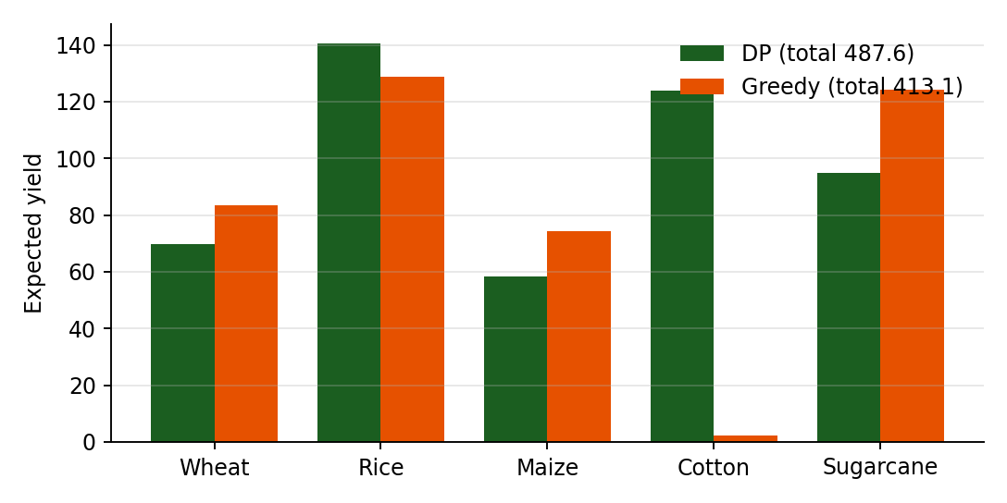
Figure 6.1: Per-crop expected yield in Case B. Greedy leaves cotton at its minimum yield (2.3) while DP funds it fully.
The explanation is visible in the greedy trace. Cotton's first extra units each add only a small amount, so the heap always preferred other crops, and cotton stayed at 4 units where its yield is close to zero. DP, by contrast, evaluates the combined effect of giving cotton eleven units, sees the large payoff beyond the threshold, and recovers it by taking water from wheat, maize and sugarcane. This is the practical consequence of non-concavity and is exactly why DP is the reference method.

6.4 Infeasible Input
With the Case A crops and W = 15 the minimums total 20 units. The feasibility check returns false before any optimization, and the interface reports a shortfall of 5 units. Both planners were also checked to return "infeasible" rather than an invalid allocation.

6.5 Randomised Verification
To go beyond hand-picked cases, 200 random instances with four crops each were generated for two families: concave-only and mixed concave/sigmoid. Each had random minimums (1–4), maximums (minimum + 3 to 7), yield parameters and a water budget between 3 and 12 units above the sum of minimums. Every instance was solved by DP, greedy and exhaustive search.
Family | DP = brute force | Greedy = DP | Average gap | Worst gap
Concave only | 200 / 200 | 200 / 200 | 0.00% | 0.00%
Mixed concave / sigmoid | 200 / 200 | 87 / 200 | 5.17% | 40.23%
Table 6.5: Randomised comparison against exhaustive search (gap = (DP − Greedy) / DP).
DP matched the exhaustive optimum in all 400 instances, supporting its correctness. Greedy was optimal on every concave instance, confirming the theory, and was optimal on only 43.5% of the mixed instances. Its average loss of about 5% is modest, but the worst case of about 40% shows that unconditional use of greedy on threshold crops can be costly.

6.6 Test Cases
ID | Scenario | Expected result | Outcome
T1 | Σ minimums > W | Rejected as infeasible with shortfall message | Pass
T2 | Σ minimums = W | Allocation equals the minimums; no free water | Pass
T3 | Single crop | All water up to M_i goes to that crop | Pass
T4 | W larger than Σ M_i | All crops at maximum; leftover water reported | Pass
T5 | m_i = M_i for a crop | Crop fixed at that value in both algorithms | Pass
T6 | Concave curves, n = 5 | Greedy = DP = brute force (Case A) | Pass
T7 | Sigmoid curves, n = 5 | DP = brute force; greedy ≤ DP (Case B) | Pass
T8 | 200 random concave instances | Greedy = DP in all | Pass
T9 | 200 random mixed instances | DP = brute force in all | Pass
T10 | Invalid input (m_i > M_i, negative W) | Validation error, no run | Pass

6.7 Performance
Running time was measured for growing problem sizes with W scaled together with the number of crops. Each value is a single timed run on one machine and should be read as indicative rather than as a formal benchmark.
Crops (n) | Water (W) | DP time (ms) | Greedy time (ms) | Speed-up | Yield (DP)
5 | 50 | 1.83 | 0.09 | 21x | 556.8
10 | 100 | 8.66 | 0.17 | 50x | 998.5
20 | 200 | 35.84 | 0.36 | 100x | 1873.0
40 | 400 | 77.16 | 0.37 | 206x | 4196.0
80 | 800 | 279.74 | 0.74 | 380x | 7921.6
Table 6.6: Measured runtimes for concave instances (greedy and DP yields agree in all rows).
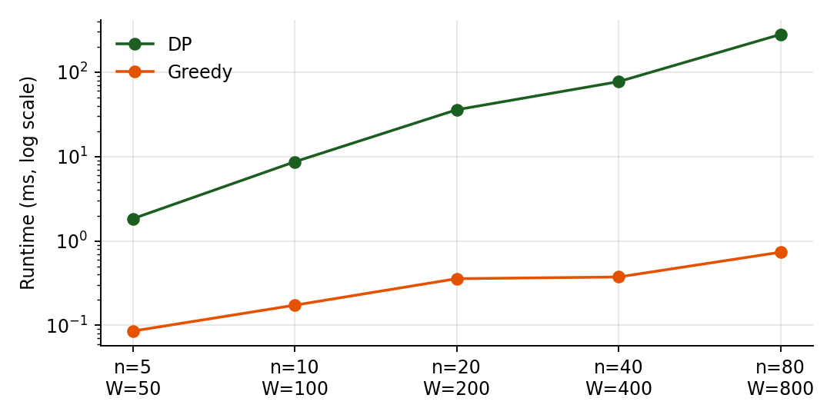
Figure 6.2: Runtime on a logarithmic scale. DP grows steeply with n and W, greedy stays near-flat.
DP time grows roughly in proportion to n · W · K as predicted: multiplying both n and W by 2 raises the cost several-fold. Greedy remains in the order of a millisecond even at n = 80 and W = 800. For the intended usage of tens of crops and a few hundred units, DP stays well under the one-second target in NFR-02.

6.8 Discussion
- Correctness: DP is the dependable reference; agreement with brute force on 400 random cases supports this.
- Speed vs. accuracy: greedy is far faster but only safe for concave yields. The system can use greedy as a quick preview and DP for the final plan.
- Explainability: both trails make the result auditable; the greedy trace is shorter and easier to read, the DP table is more complete.
- Practical guidance: if all crop curves are known to show diminishing returns, greedy is justified; if any crop has a threshold effect, DP should be used.

6.9 Threats to Validity
- Yield curves are synthetic; real agronomic data may differ in shape and noise.
- Timings come from a single machine and run; relative trends matter more than absolute numbers.
- Random instances use only four crops so that brute force remains feasible.

7. Conclusion, Future Scope & References

7.1 Conclusion
This project turned the requirement "allocate limited water across crops to maximize expected yield while satisfying minimum irrigation requirements" into a working prototype built with Python, Flask and SQLite. Minimum irrigation is enforced by reserving each crop's minimum and, inside the DP recurrence, by treating budgets that cannot satisfy the minimums as infeasible.
Dynamic Programming solved the allocation exactly by storing sub-problem results and reconstructing the final decisions from them; it matched exhaustive search in all test cases. The Greedy planner, which repeatedly picks the crop with the highest marginal gain, matched DP whenever yield curves were concave and ran up to several hundred times faster, but lost up to about 40% of the yield on instances with threshold crops. In the main non-concave case it fell short by about 15%.
Equally important, the system does not just return a number. It shows the DP table and path, the ordered greedy choices and the comparison between the two, so the user can see why a particular allocation was selected. The project therefore meets its objectives: it maximizes expected yield, respects minimum irrigation, demonstrates two core DAA techniques and compares them on the same input.

7.2 Future Scope
- Economic objective: replace yield by profit using crop prices and water costs, or add a cost-minimisation objective.
- Real data: fit yield curves from field trials or crop-water-production functions published by agricultural agencies.
- Uncertainty: model rainfall and yield as random variables and maximise expected value or minimise risk.
- Multi-period planning: allocate water across weeks with growth-stage sensitivity, extending the DP with a time dimension.
- Multiple resources: add fertiliser, labour or land constraints, leading to multi-dimensional DP or integer programming.
- Faster exact methods: use divide-and-conquer or monotonicity optimisations to reduce DP time, or convexification to extend greedy.
- Integration: pull soil-moisture and weather feeds, add a map view and mobile access.
- Hybrid planner: automatically select greedy when all curves are concave and DP otherwise.

7.3 References
- T. H. Cormen, C. E. Leiserson, R. L. Rivest and C. Stein, Introduction to Algorithms, 4th ed., MIT Press, 2022.
- A. Levitin, Introduction to the Design and Analysis of Algorithms, 3rd ed., Pearson, 2012.
- J. Kleinberg and É. Tardos, Algorithm Design, Pearson, 2005.
- S. Dasgupta, C. Papadimitriou and U. Vazirani, Algorithms, McGraw-Hill, 2006.
- R. Bellman, Dynamic Programming, Princeton University Press, 1957.
- H. Kellerer, U. Pferschy and D. Pisinger, Knapsack Problems, Springer, 2004.
- FAO, Crop Yield Response to Water, FAO Irrigation and Drainage Paper 66, Food and Agriculture Organization of the United Nations, 2012.
- Flask Documentation, Pallets Projects, https://flask.palletsprojects.com.
- SQLite Documentation, https://www.sqlite.org/docs.html.
- Python Documentation: heapq and sqlite3 modules, https://docs.python.org/3/.

